Ai Assisted Coding
Name :C. Vaishnav Reddy
HallTicket:2303A52203
Batch:45

Problem1:-
Consider the following Python function:
def reverse_string(text):
return text[::-1]
Task:
1. Write documentation in:
o (a) Docstring
o (b) Inline comments
o (c) Google-style documentation
2. Compare the three documentation styles.
3. Recommend the most suitable style for a utility-based string
library.
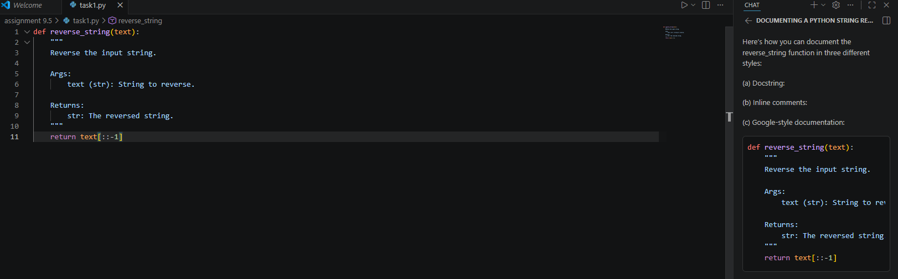
Comparison:
- Docstring: Placed inside the function, readable by help() and documentation tools. Good for describing purpose, parameters, and return values.
- Inline comments: Placed beside or above code lines. Useful for explaining complex logic, but not for overall function purpose.
- Google-style: A specific docstring format that is clear, structured, and widely used in professional Python codebases.
Recommendation:
For a utility-based string library, Google-style docstrings are most suitable. They are standardized, tool-friendly, and provide clear, structured documentation for each function.
Problem 2: Password Strength Checker
Consider the function:
def check_strength(password):
return len(password) >= 8
Task:
1. Document the function using docstring, inline comments, and
Google style.
2. Compare documentation styles for security-related code.
3. Recommend the most appropriate style.
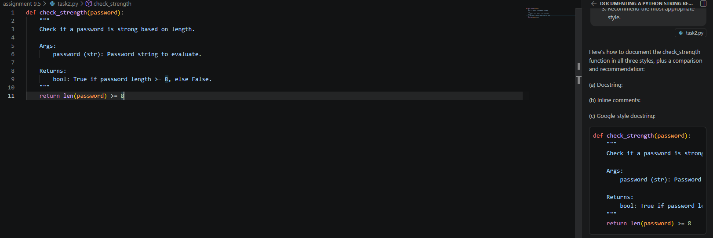
Comparison for security-related code:
- Docstrings (especially Google-style) provide clear, structured documentation, making it easy to understand function intent, parameters, and return values.
- Inline comments are helpful for clarifying specific logic, but do not provide an overview or are not accessible via documentation tools.
- Google-style docstrings are especially useful for security code, as they can include warnings, usage notes, and are compatible with automated documentation tools.
Recommendation:
For security-related code, Google-style docstrings are most appropriate. They ensure clarity, support for automated documentation, and can include important security notes or warnings.
Problem 3: Math Utilities Module
Task:
1. Create a module math_utils.py with functions:
o square(n)
o cube(n)
o factorial(n)
2. Generate docstrings automatically using AI tools.
3. Export documentation as an HTML file.
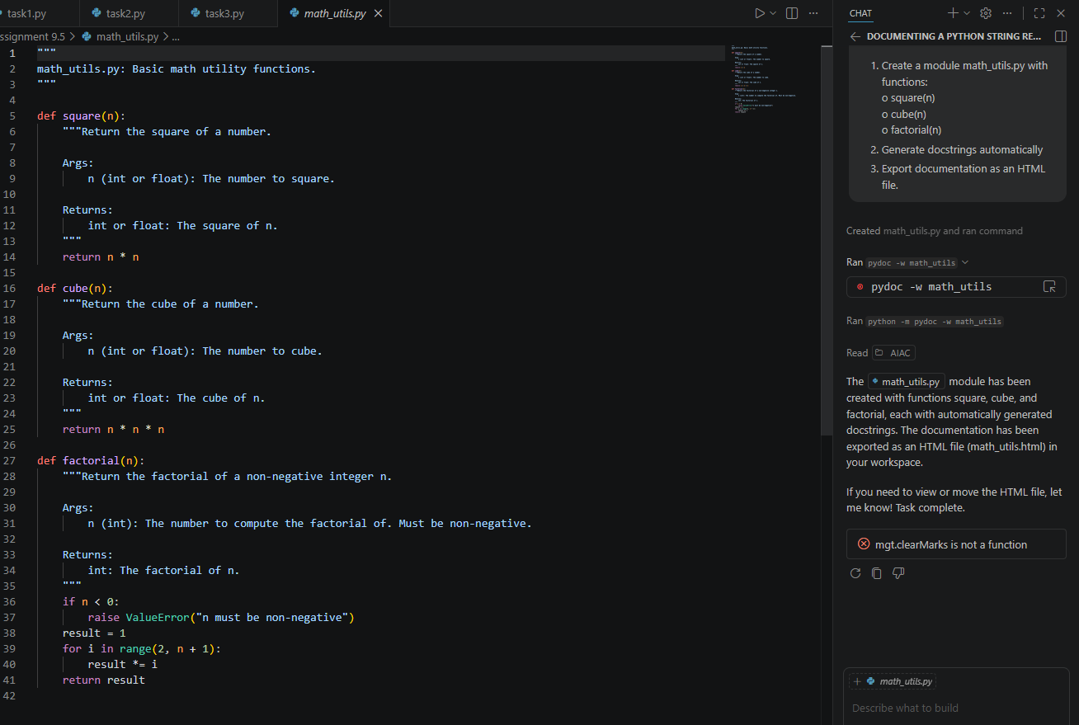
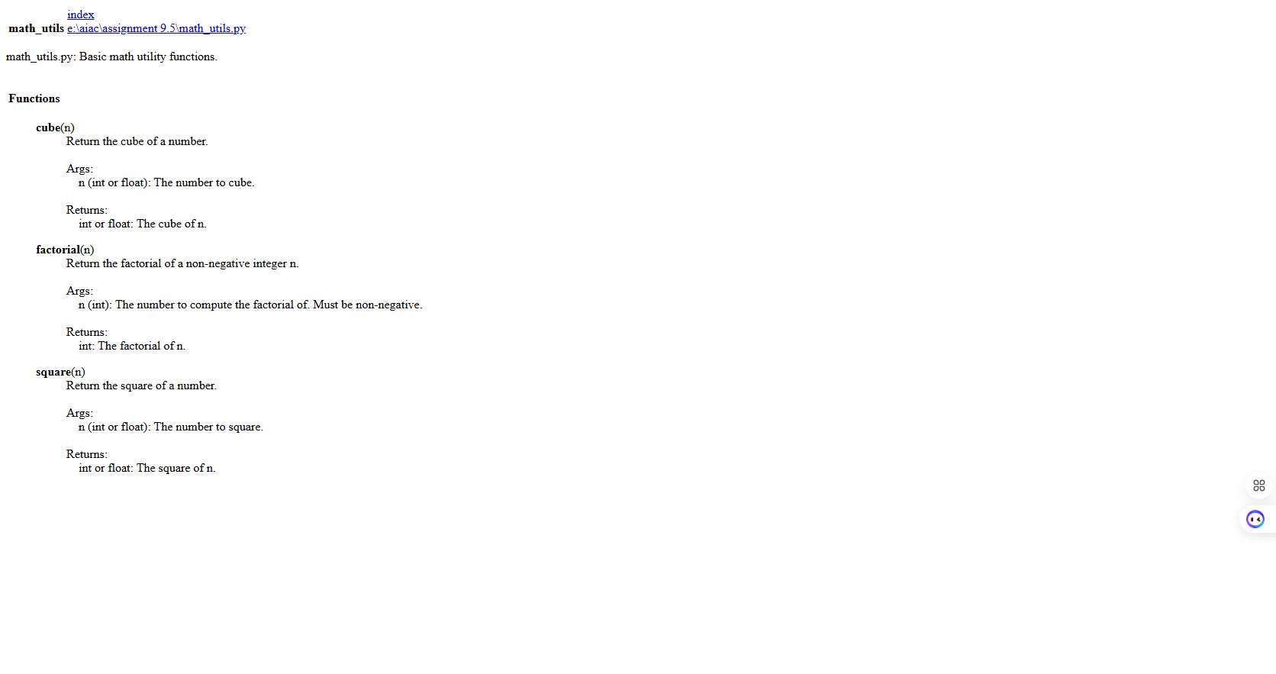
Problem 4: Attendance Management Module
Task:
1. Create a module attendance.py with functions:
o mark_present(student)
o mark_absent(student)
o get_attendance(student)
2. Add proper docstrings.
3. Generate and view documentation in terminal and browse
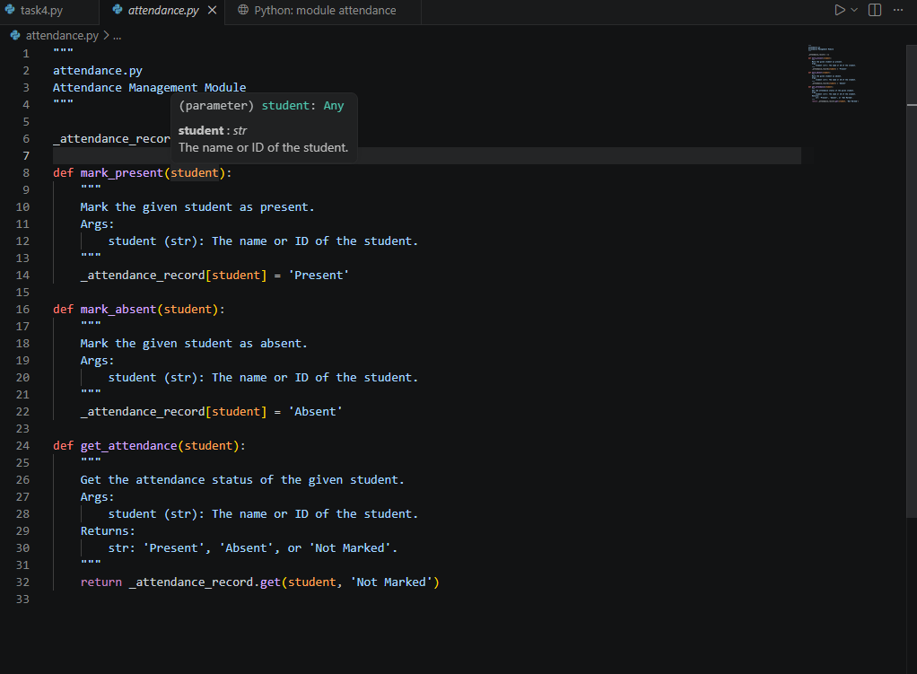
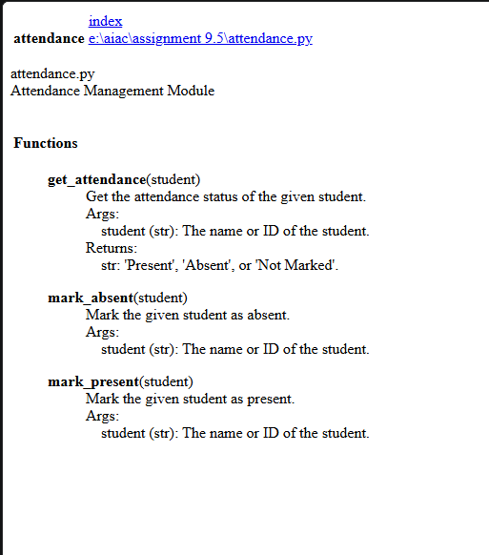
Problem 5: File Handling Function
Consider the function:
def read_file(filename):
with open(filename, 'r') as f:
return f.read()
Task:
1. Write documentation using all three formats.
2. Identify which style best explains exception handling.
3. Justify your recommendation.

1.

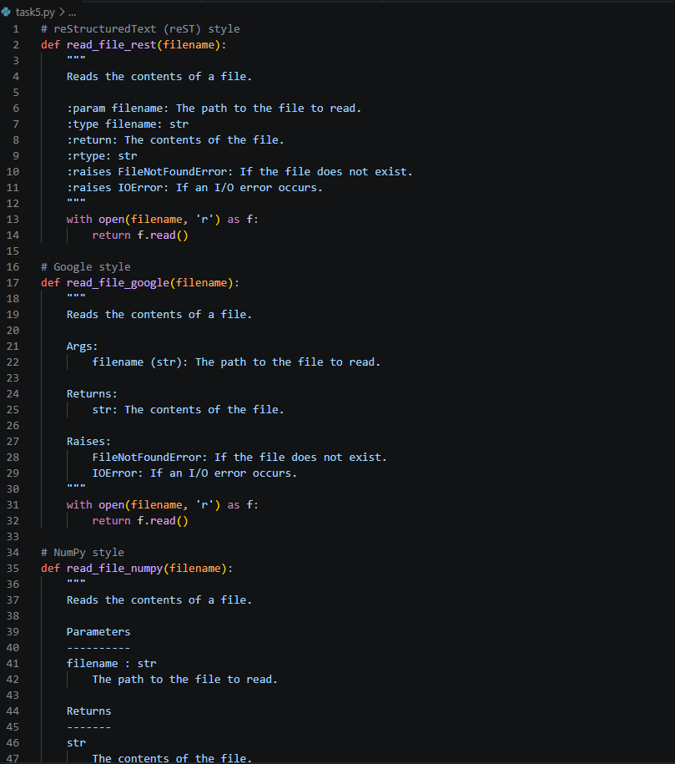
2. Which style best explains exception handling?
All three styles allow you to document exceptions, but the NumPy and Google styles are the clearest and most widely supported by documentation tools and IDEs. They both use a dedicated "Raises" section, making it easy to spot exception information.

3. Recommendation and Justification:
I recommend the Google style for most projects. It is concise, easy to read, and clearly separates arguments, return values, and exceptions. The "Raises" section is explicit, making exception handling easy to understand for users and tools alike. This style is also widely supported by documentation generators and IDEs.

